

**AMERICAN INTERNATIONAL UNIVERSITY- BANGLADESH**

**(AIUB)**

**Introduction to Electrical Circuit**

**FALL 2023-2024**

**Section: L, Group: 07**

**LAB REPORT ON**

***Analysis of RC, RL, RLC series circuits and verification of KVL in RLC series Circuit related to AC circuit***

**Supervised By**

**MD. SHAHARIAR PARVEZ**

|  |  |
| --- | --- |
| **Name** | **ID** |
| **1.MD. Abdullah** | **22-48065-2** |
| **2.Azmir Islam Kafi** | **22-47981-2** |
| **3.Mohammad Ansar Uddin** | **22-47975-2** |
| **4.Chinmoy Guha** | **22-48056-2** |
| **5.Suvra Chakraborty** | **22-48067-2** |

***Abstract:***

The experiment aimed to develop an understanding of circuits containing R, L, and C components. The objective was to analyze the outputs of RC and RL series circuits practically, comparing them with simulated or theoretical results. Additionally, the experiment sought to determine the phase relationship between voltage (V) and current (I) in an RLC series circuit. Lastly, the goal was to draw a complete vector diagram and verify Kirchhoff's Voltage Law (KVL) for an RLC series circuit based on the experimental findings.

The RC & RL circuit is used to determine the input and output relationship of voltage and current for different frequencies. In RC series circuit the voltage lags the current by 90˚and in RL series circuit the voltage leads the current by 90˚.

An RLC circuit is an electrical circuit consisting of a resistor, an inductor, and a capacitor, connected in series. The RLC part of the name is due to those letters being the usual electrical symbols for resistance, inductance and capacitance respectively. Series RLC circuits are classed as second-order circuits because they contain two energy storage elements, an inductance and a capacitance.

***Circuit diagram:***

***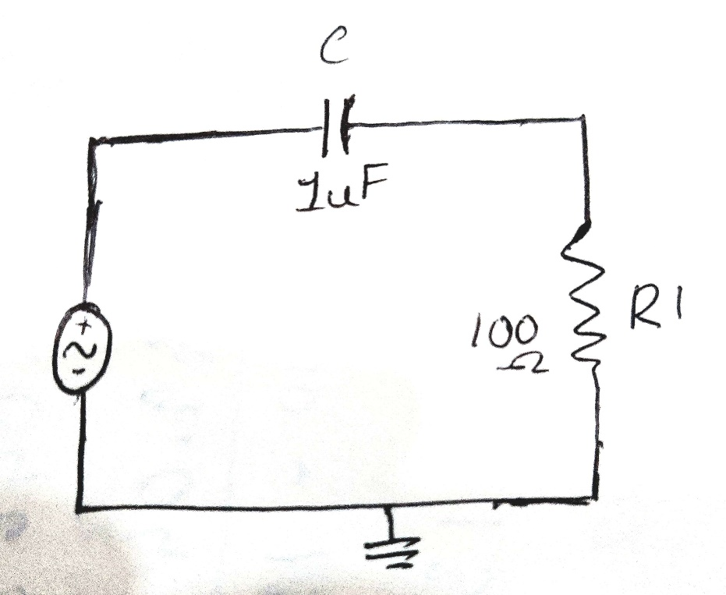  
Figure 1: RC circuit***

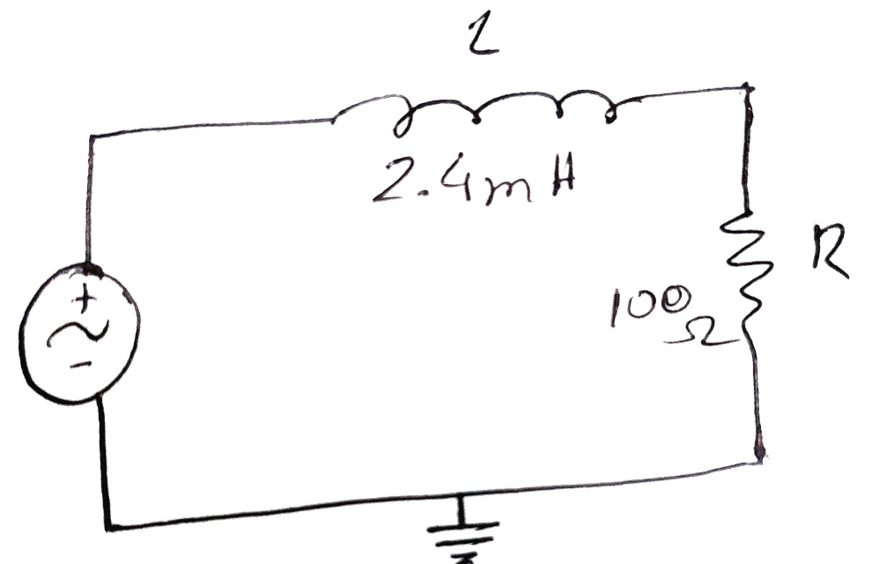

***Figure 2: RL circuit***

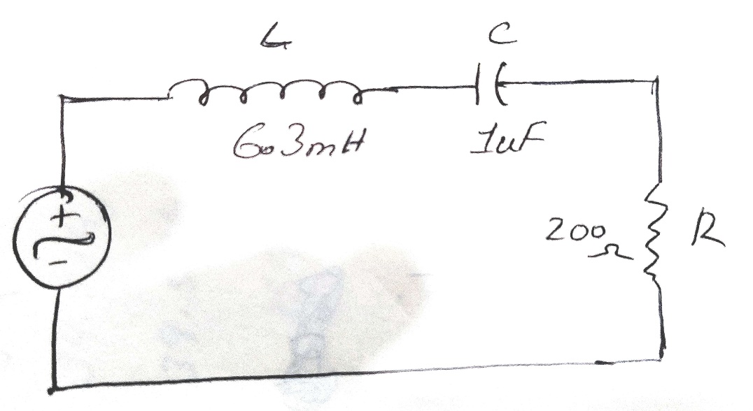

***Figure 2: RLC circuit***

**Apparatus:**

• Oscilloscope

• Function generator

• Resistor: 100  (For RC and RL)

• Inductor: 2.4mH (For RC and RL)

• Capacitor: 1 F/ 10 F (For RC and RL)

• Resistor (200 ) For RLC

• Inductor (6.3 mH) For RLC

• Capacitor (1 uF) For RLC

• Connecting wire

• Bread board

***Experimental Procedure:***

The circuit was constructed as depicted in Fig. 1. Channel 1 of the oscilloscope was connected across the function generator to measure E, while channel 2 of the oscilloscope was connected across R to measure VR.

The amplitude of the input signal was set to 5V peak, and the frequency was adjusted to 1 kHz with a sinusoidal wave shape selected.

The peak values of both wave shapes were measured.

The phase relationship (θ) between the waves was determined.

Wave equations for I and E were documented.

Resistance and reactance were calculated based on the relevant data.

The same experiment was conducted with input frequencies set at 5 kHz and 10 kHz.

The table was completed with the corresponding data gathered during the experiment

The circuit was constructed according to the configuration in Fig. 2. Channel 1 of the oscilloscope was linked across the function generator, and channel 2 was connected across R.

The procedures outlined in steps 2 to 7 were followed.

Now for the RLC circuit, The circuit was constructed based on the configuration illustrated in Figure 3. Channel 1 of the oscilloscope was connected across the AC voltage source, and channel 2 was linked across R.

The amplitude of the input signal was set to 5V peak.

The frequency of the signal generator was adjusted to 1 kHz, and a sinusoidal wave shape was selected.

The phase relationship (θ) between the waves was determined.

The value of current (I) was measured.

Measurements were taken for the values of VR, VL, and VC.

Kirchhoff's Voltage Law (KVL) was verified using the experimental data, and a complete vector diagram was drawn.

The frequency of the signal generator was then set to 2 kHz, and steps 4 to 7 were repeated.

The frequency of the signal generator was further adjusted to 4 kHz, and steps 4 to 7 were repeated.

The provided table was completed with the relevant data obtained during the experiment.

***Result analysis :***

**Table 1:**

For RC and RL series circuit:

|  |  |  |  |  |  |  |  |  |
| --- | --- | --- | --- | --- | --- | --- | --- | --- |
| f | E | I=VR/R  (A) | Z= *E/I*(Polar) | Z(Rectangular) | R | XC=1/2 fC | VR | VC=IXC |
| 1KHz | 5 | 0.0266 | 187.96∠ − 57.86° | 100-159.155j | 100 | 159.155 | 2.66 | 4.234 |
| 5KHz | 10 | 0.0953 | 104.94∠ − 17.66° | 100-31.831j | 100 | 31.831 | 9.53 | 3.0335 |
| 10KHz | 15 | 0.148 | 101.26∠ − 9.04° | 100-15.9155j | 100 | 15.9155 | 14.81 | 2.356 |

**Table~2**

|  |  |  |  |  |  |  |  |  |
| --- | --- | --- | --- | --- | --- | --- | --- | --- |
| f | E | I=VR/R  (A) | Z= *E/I*  (Polar) | Z(Rectangular) | R | XL=2 fL | VR | VL=IXL |
| 1KHz | 5 | 0.0494 | 101.131∠8.58° | 100+15.09j | 100 | 15.08 | 4.94 | 0.745 |
| 5KHz | 10 | 0.0799 | 125.24∠37.016 | ° 100+75.398j | 100 | 75.398 | 7.99 | 6.024 |
| 10KHz | 15 | 0.083 | 180.94∠56.45° | 100+150.797j | 100 | 150.797 | 8.3 | 12.516 |

***For RLC Series Circuit:***

**Table~3**

|  |  |  |  |  |  |  |  |  |  |
| --- | --- | --- | --- | --- | --- | --- | --- | --- | --- |
| f | E  (V) | θ = tan-1  X/R | VR  (V) | I=VR/R  (A) | XL=2 fL  ( ) | VL=IXL  (V) | XC=1/2 fC  ( ) | VC (V) | V*  (V) |
| 1kHz | 5 | ∠ − 55.236° | 2.85 | 0.0285 | 15.08 | 0.4298 | 159.155 | 4.536 | 4.998 |
| 5kHz | 10 | ∠12.927° | 9.17 | 0.0917 | 75.398 | 6.914 | 31.831 | 2.919 | 10.002 |
| 10kHz | 15 | ∠53.447° | 8.93 | 0.0893 | 150.797 | 13.466 | 15.9155 | 1.421 | 14.994 |

***Simulation:  
  
TABLE 1:***

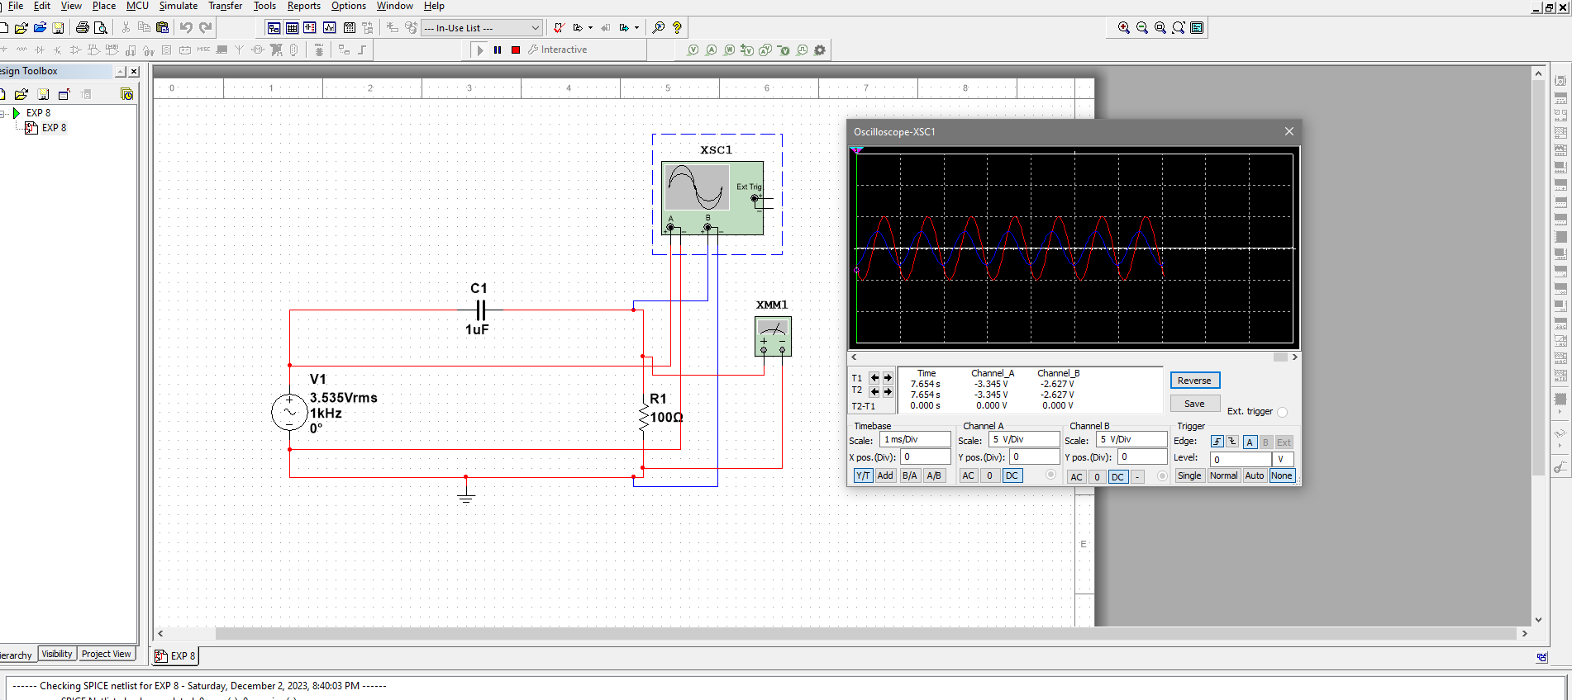

***Figure: Frequency 1kHz***

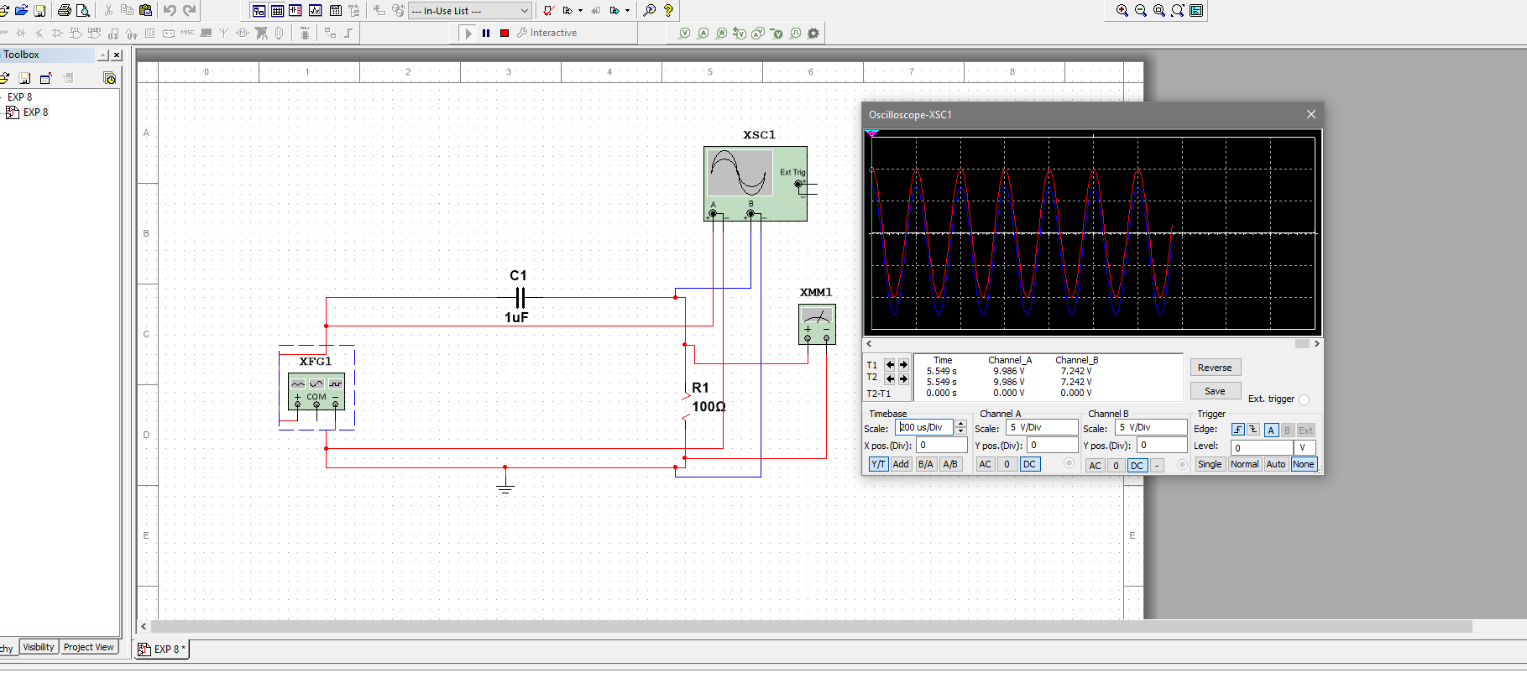

***Figure: Frequency 5kHz***

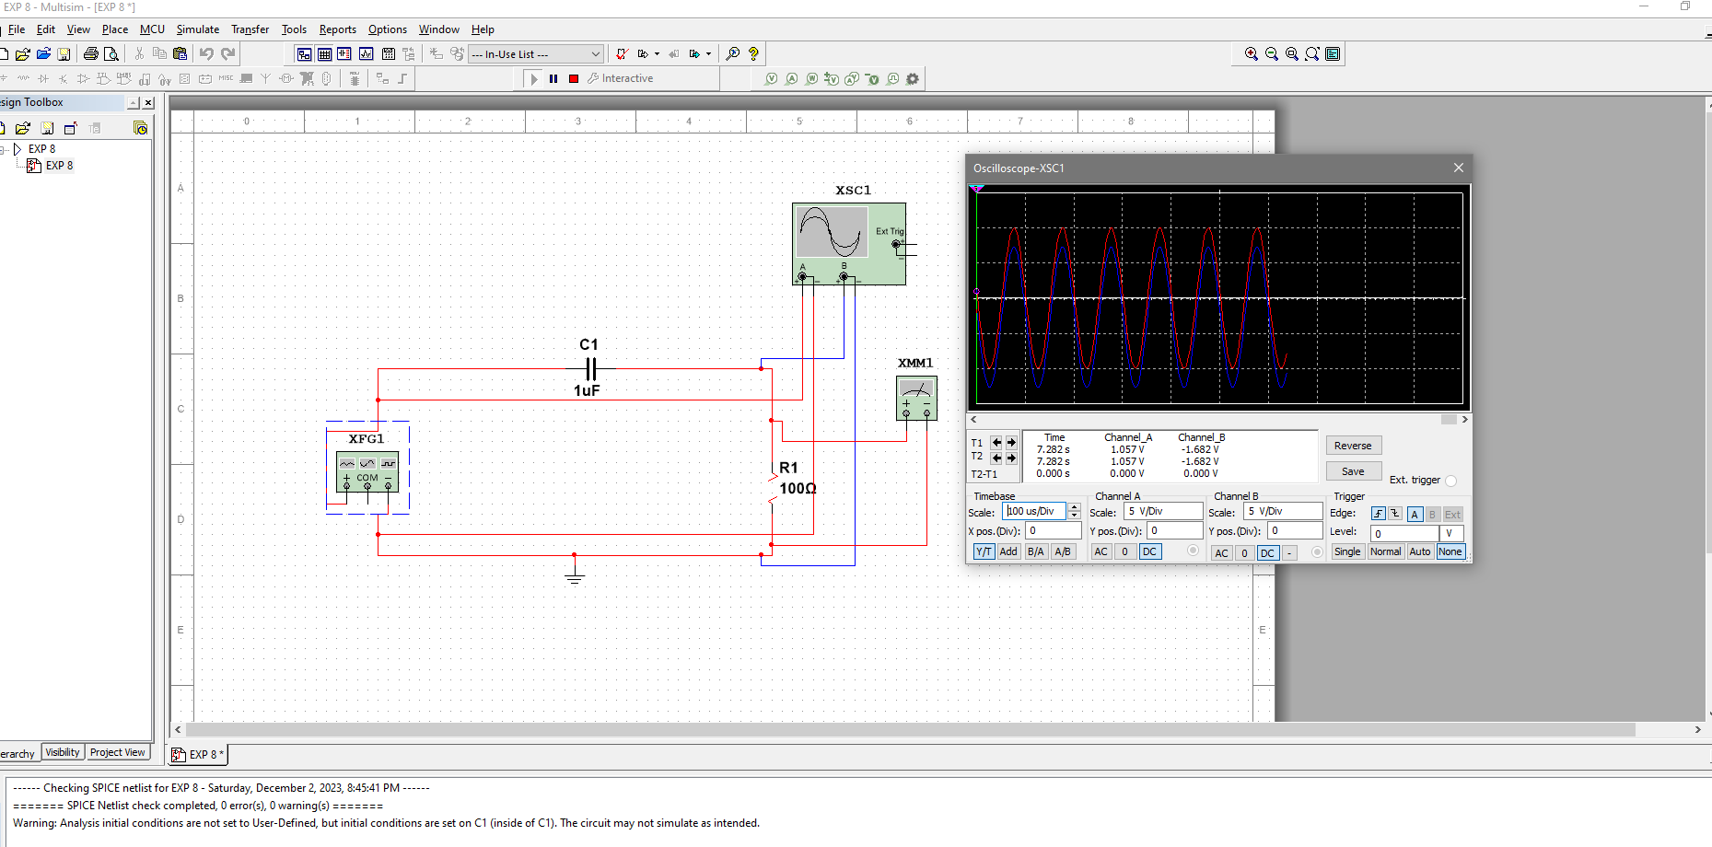

***Figure: Frequency 10kHz***

***TABLE 2:***

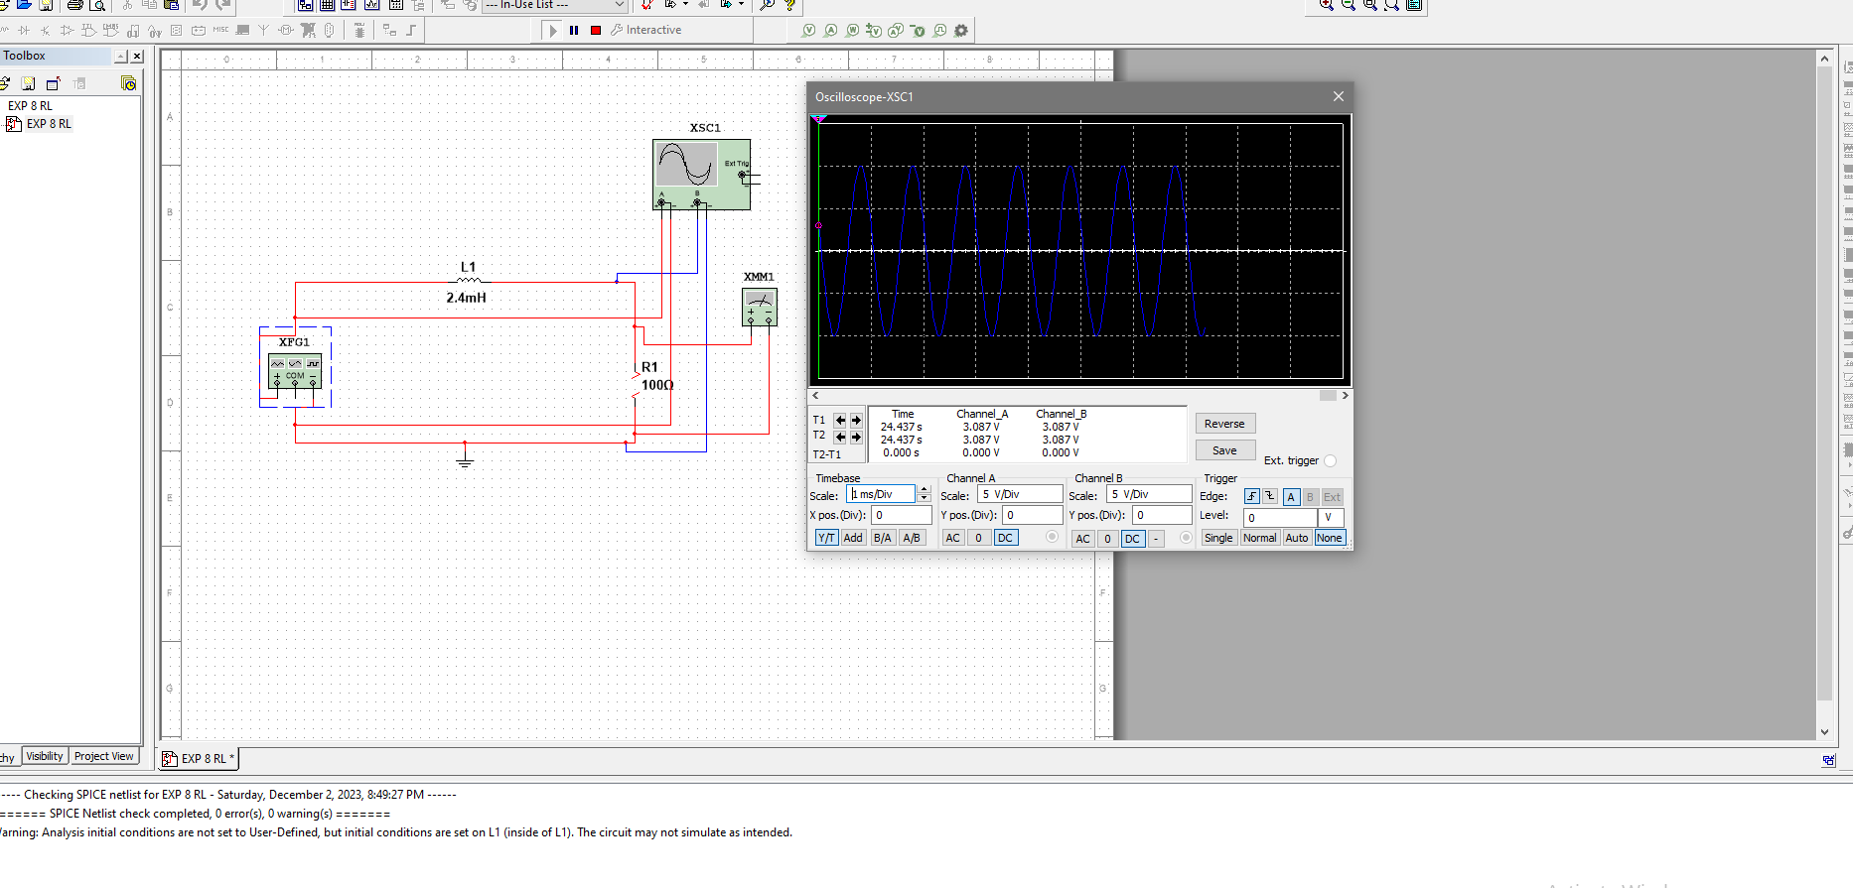

***Figure: Frequency 1kHz***

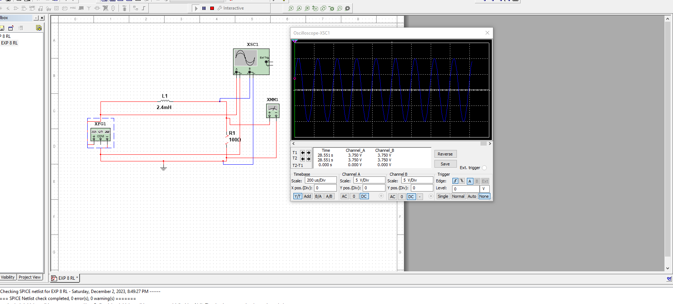

***Figure: Frequency 5kHz***

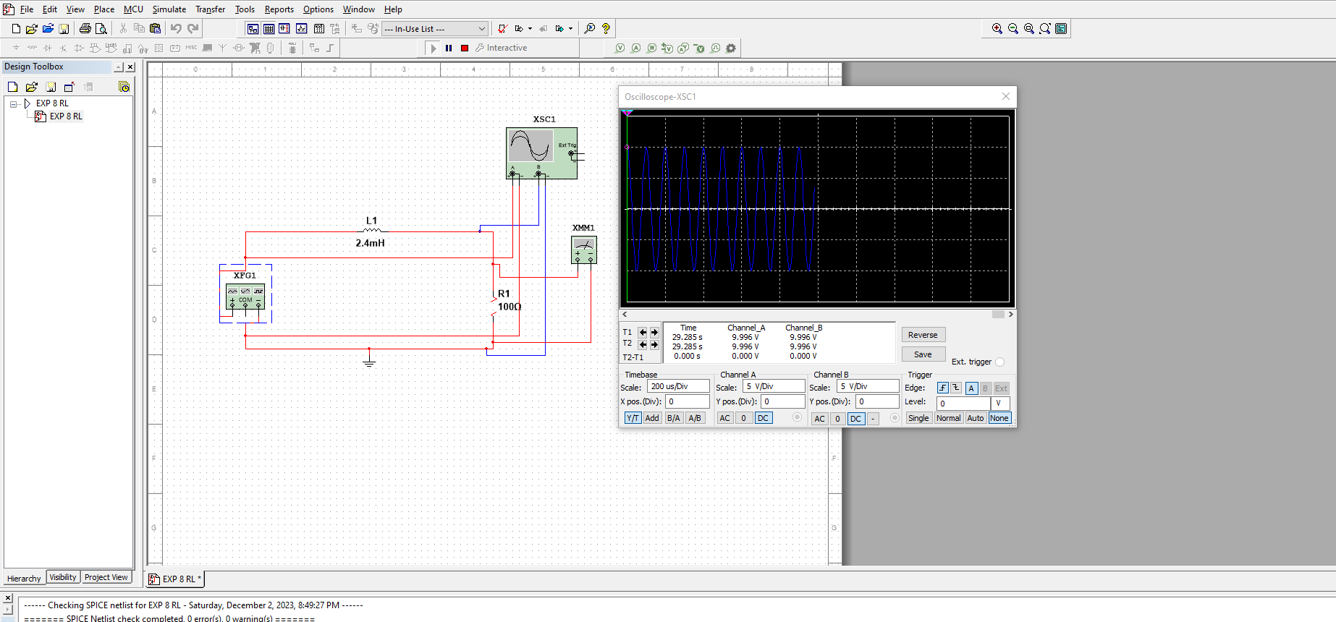

***Figure: Frequency 10kHz***

***TABLE 3 (RLC):***

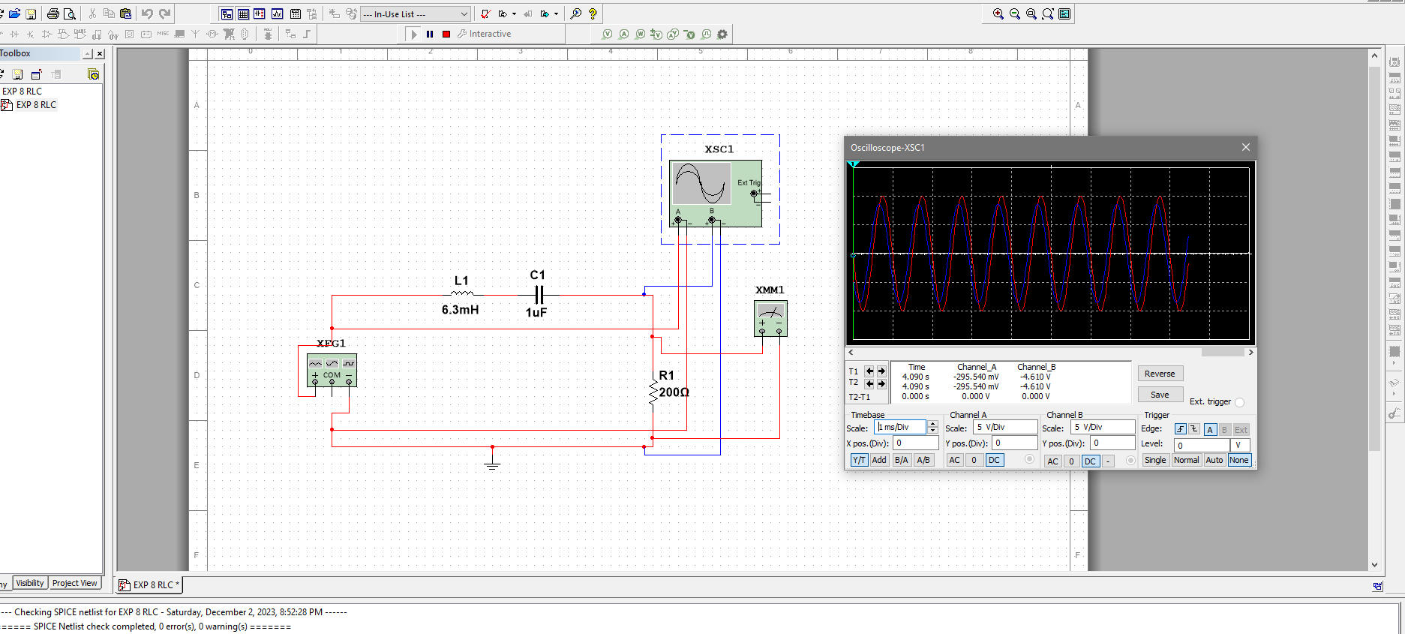

***Figure: Frequency 1kHz***

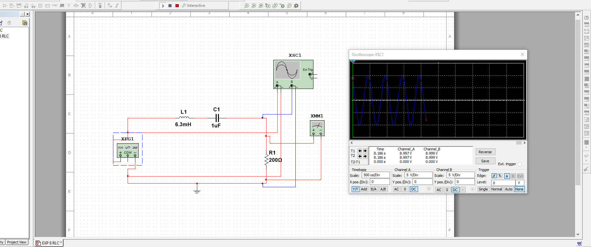

***Figure: Frequency 2kHz***

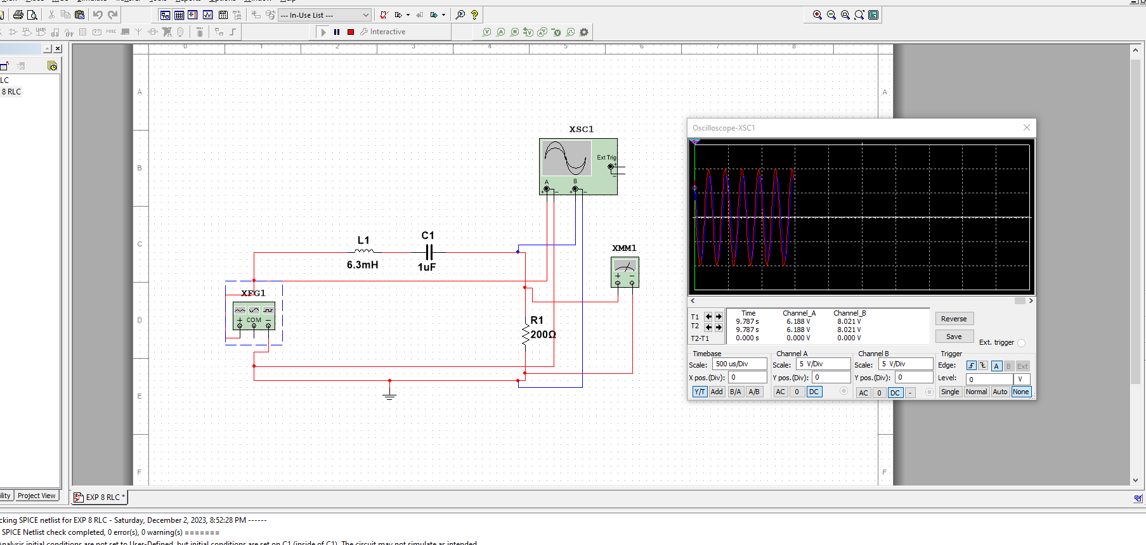

***Figure: Frequency 4kHz***

***Calculation:***

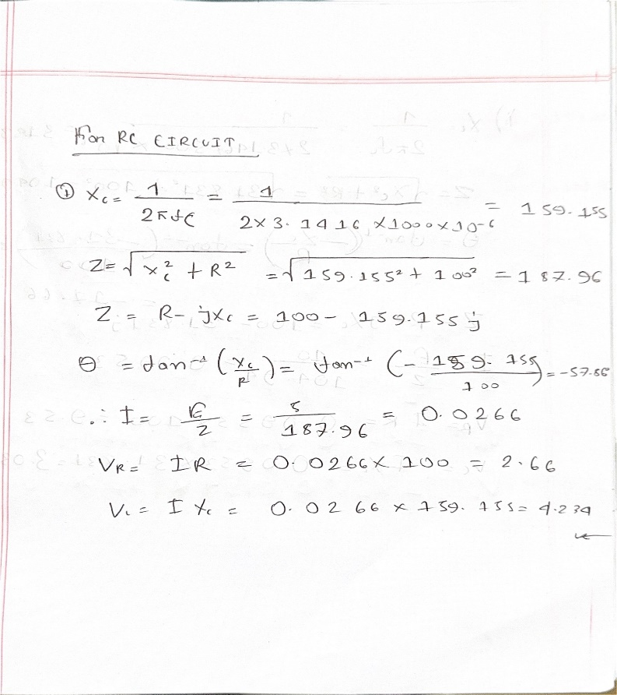

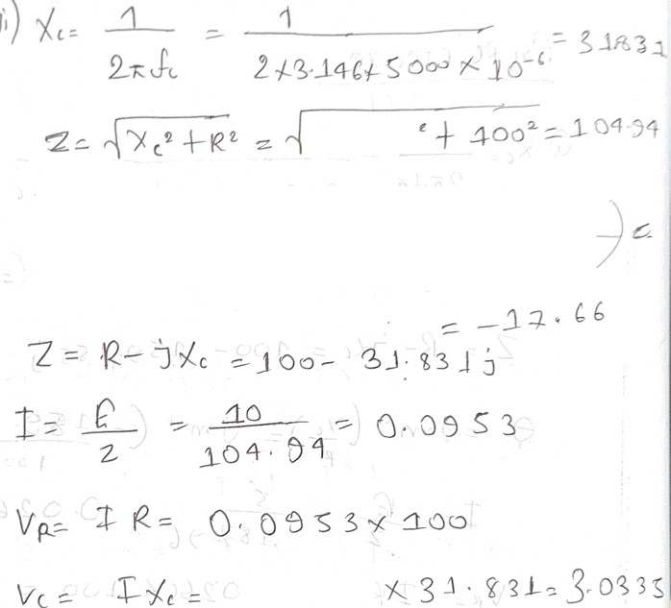

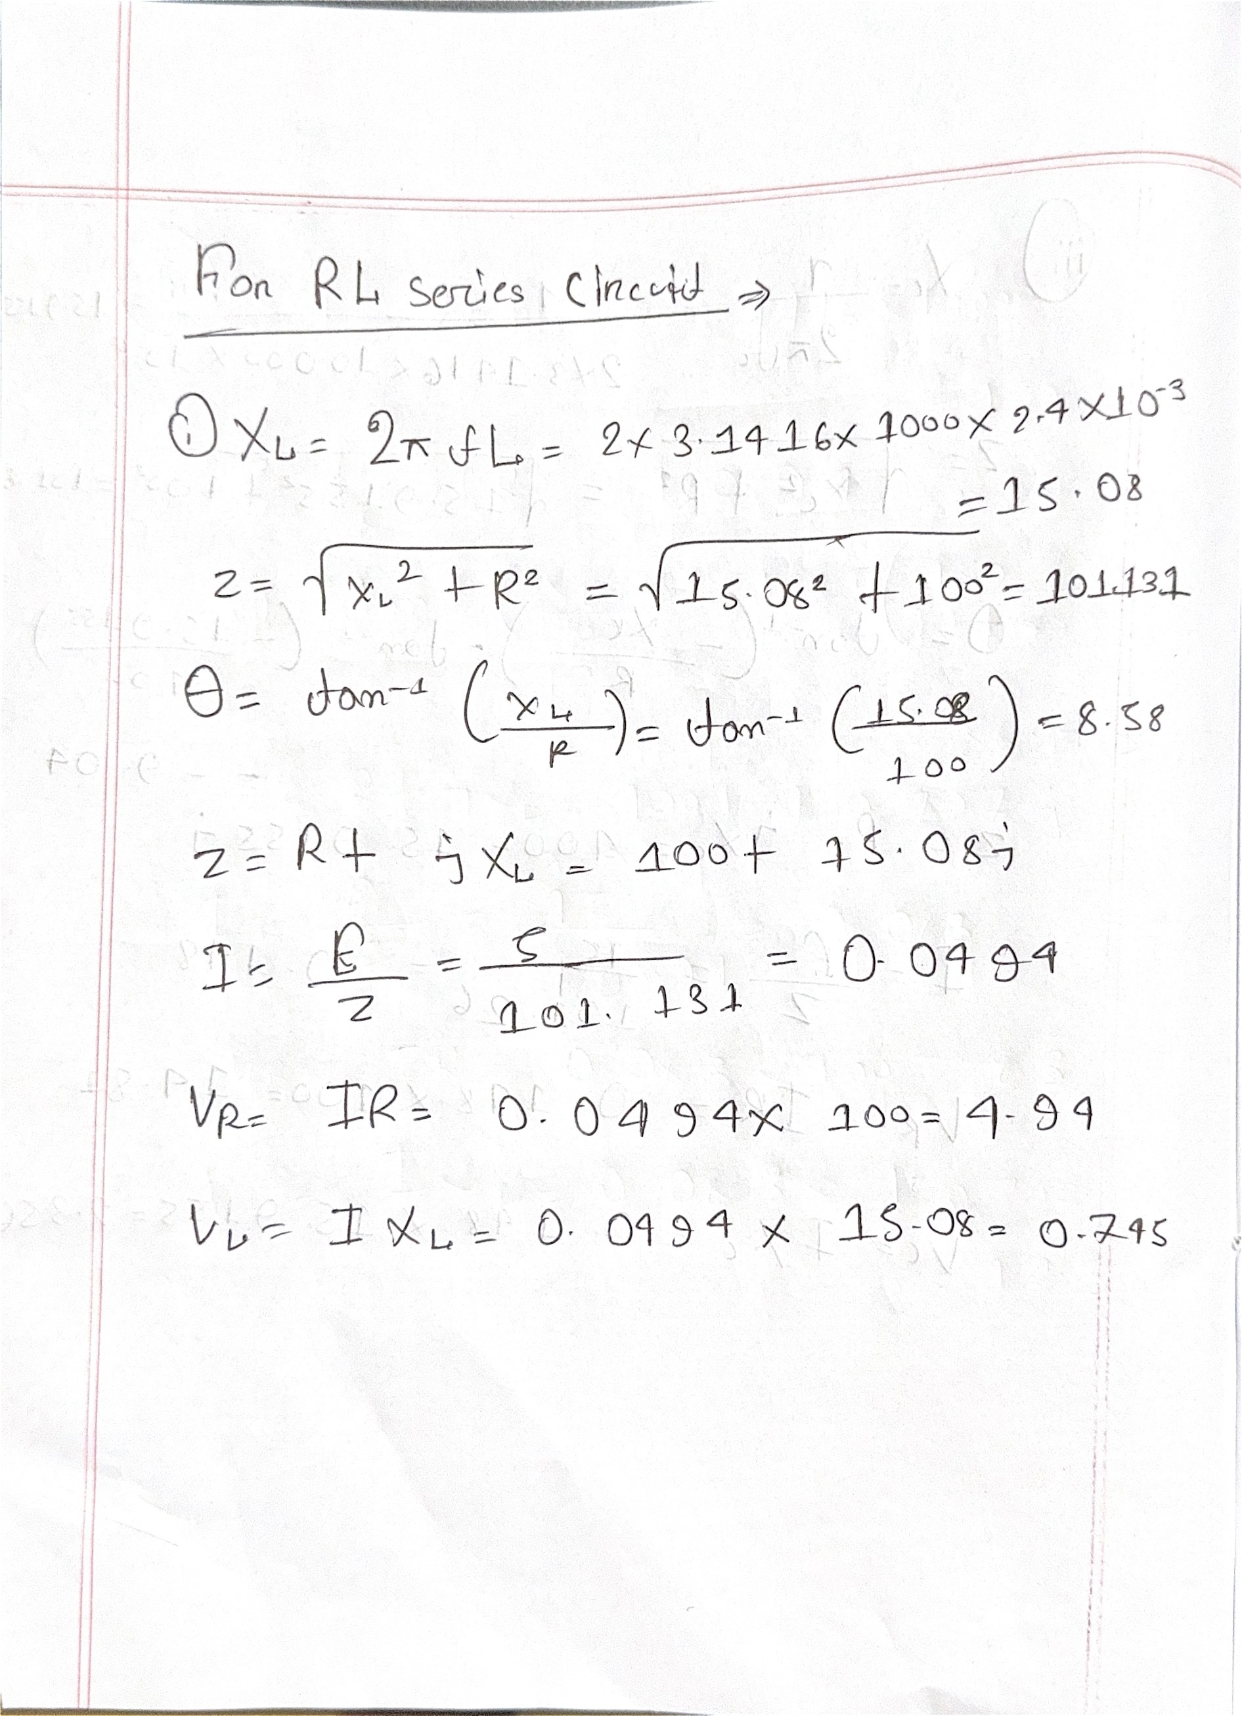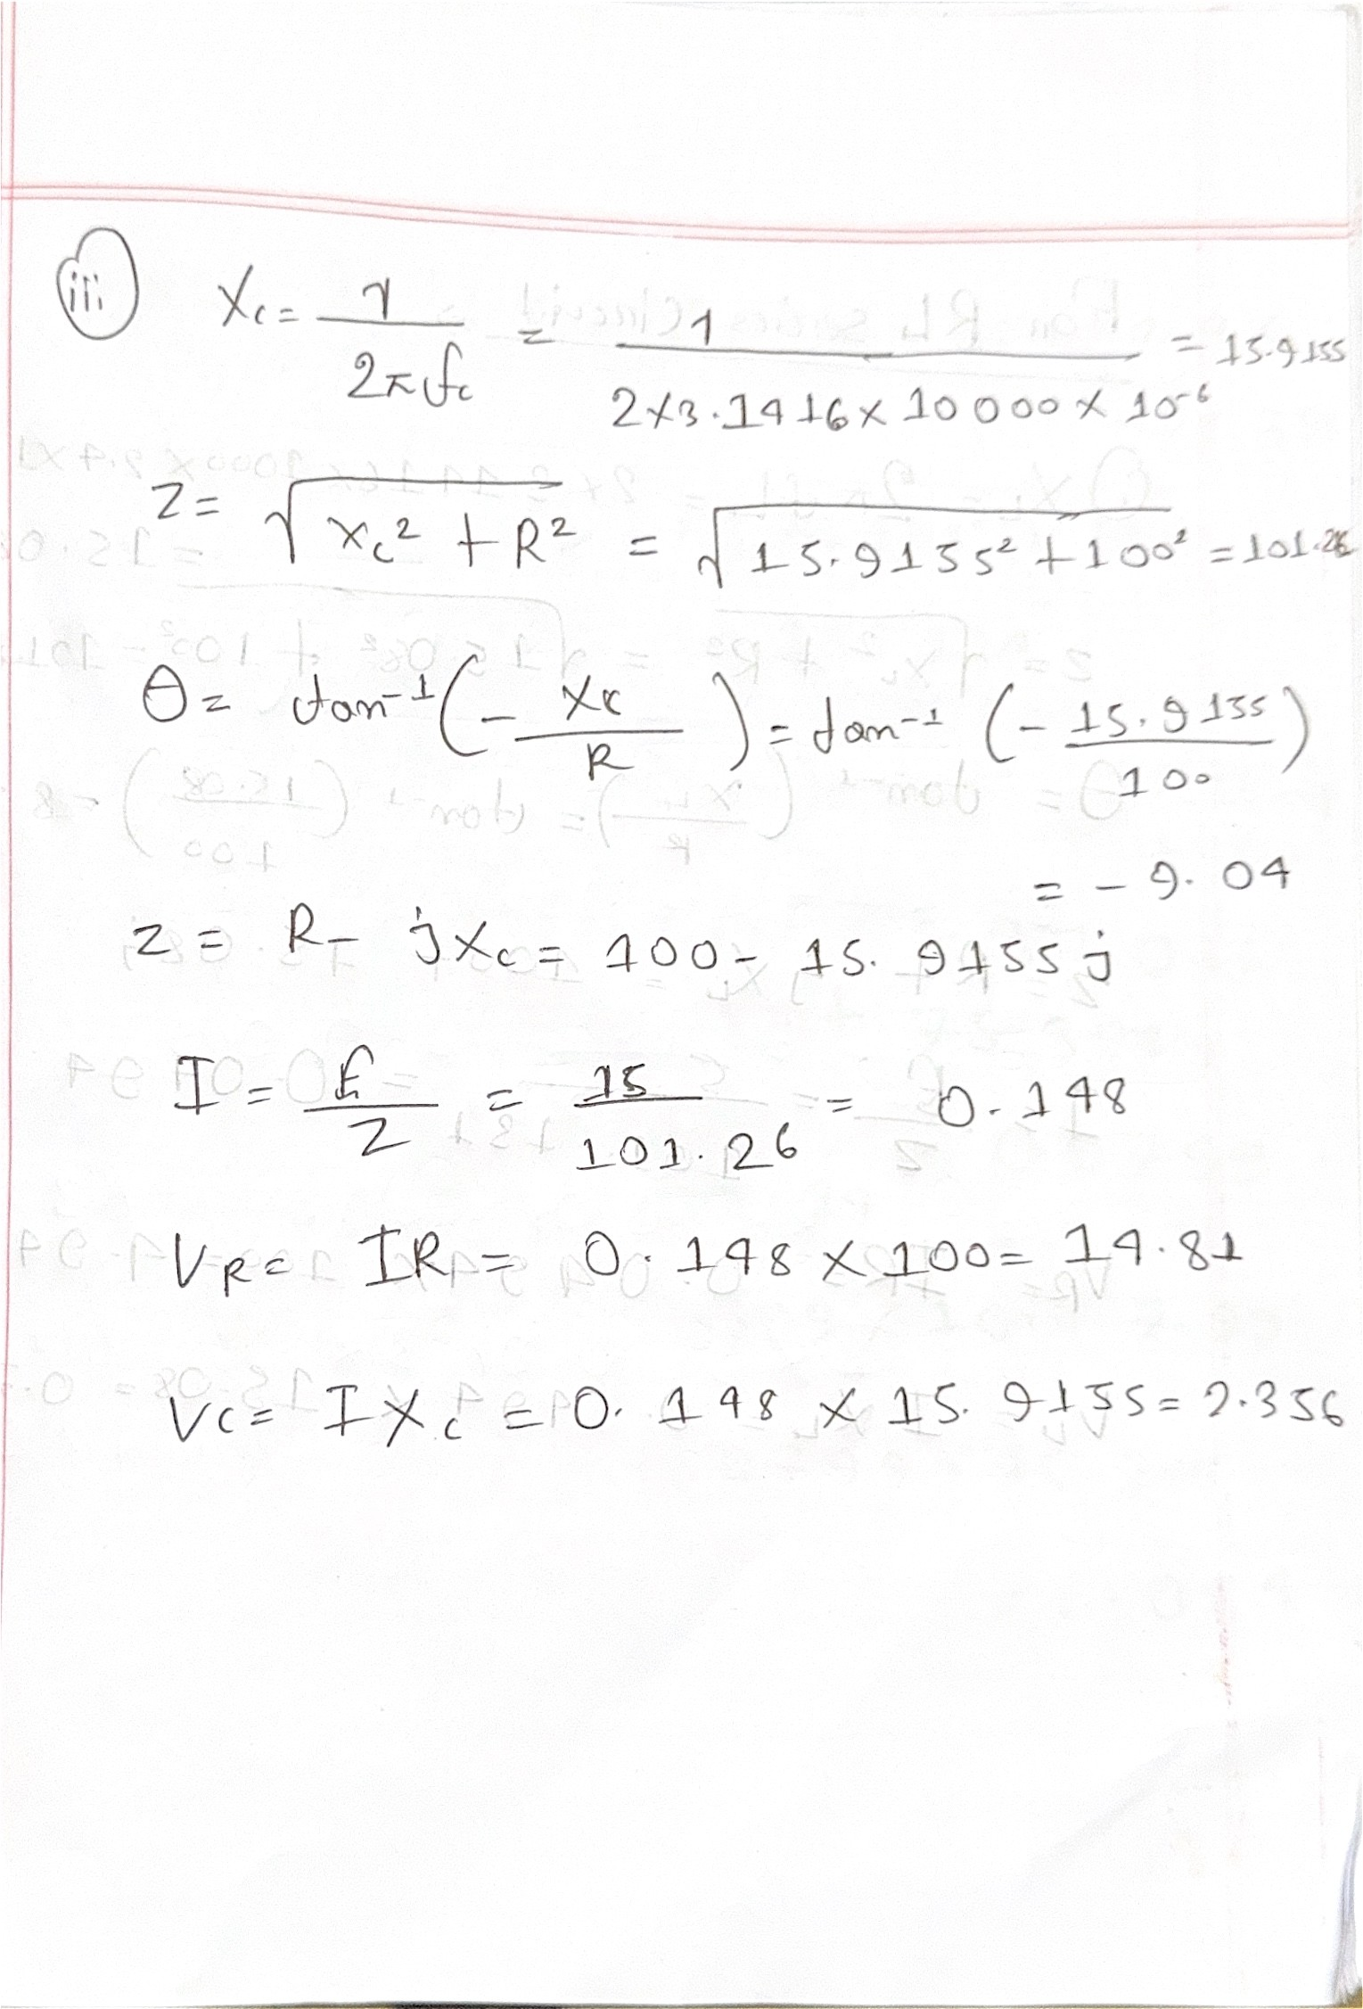

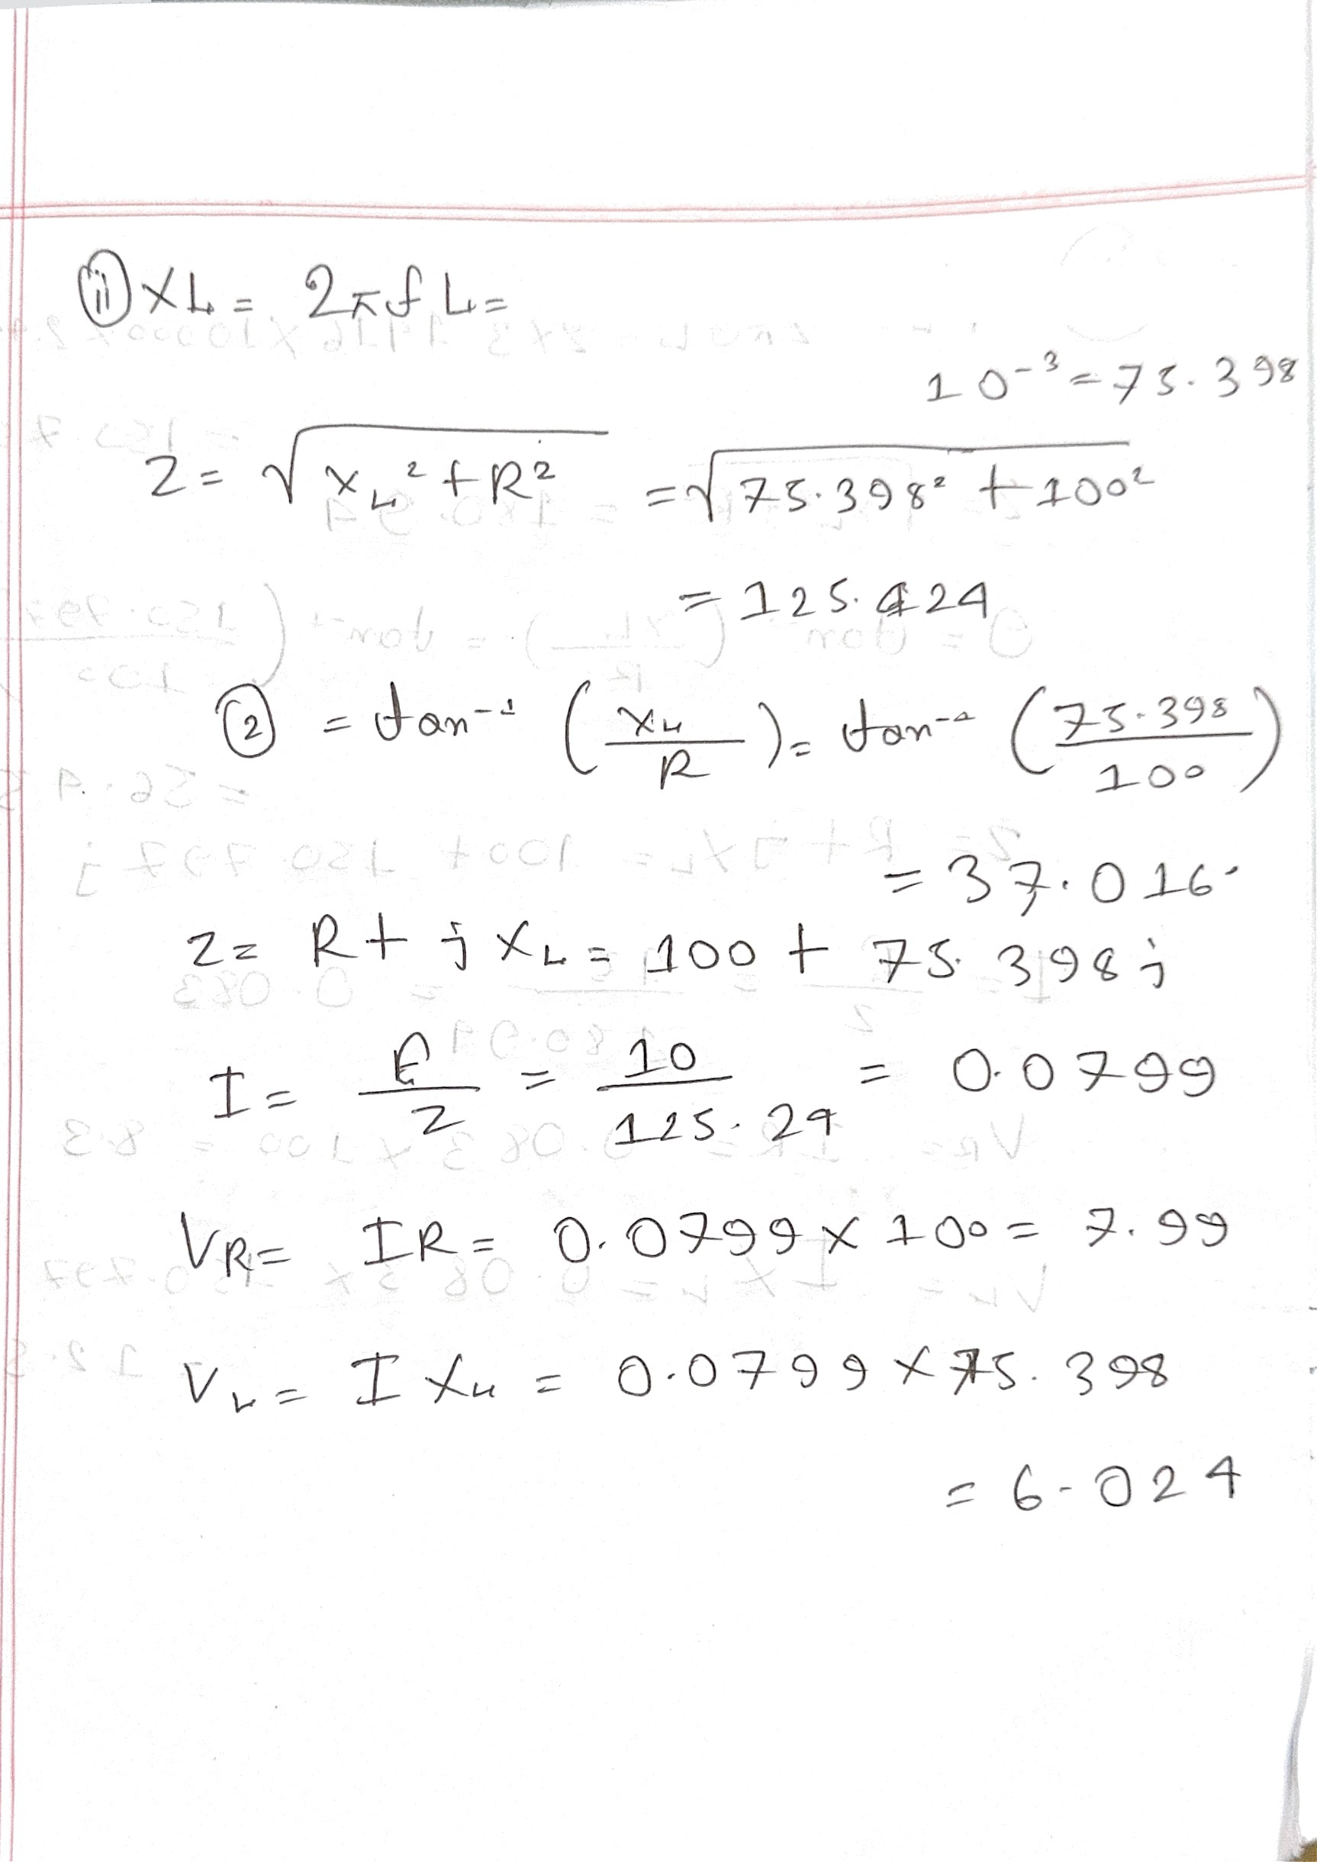

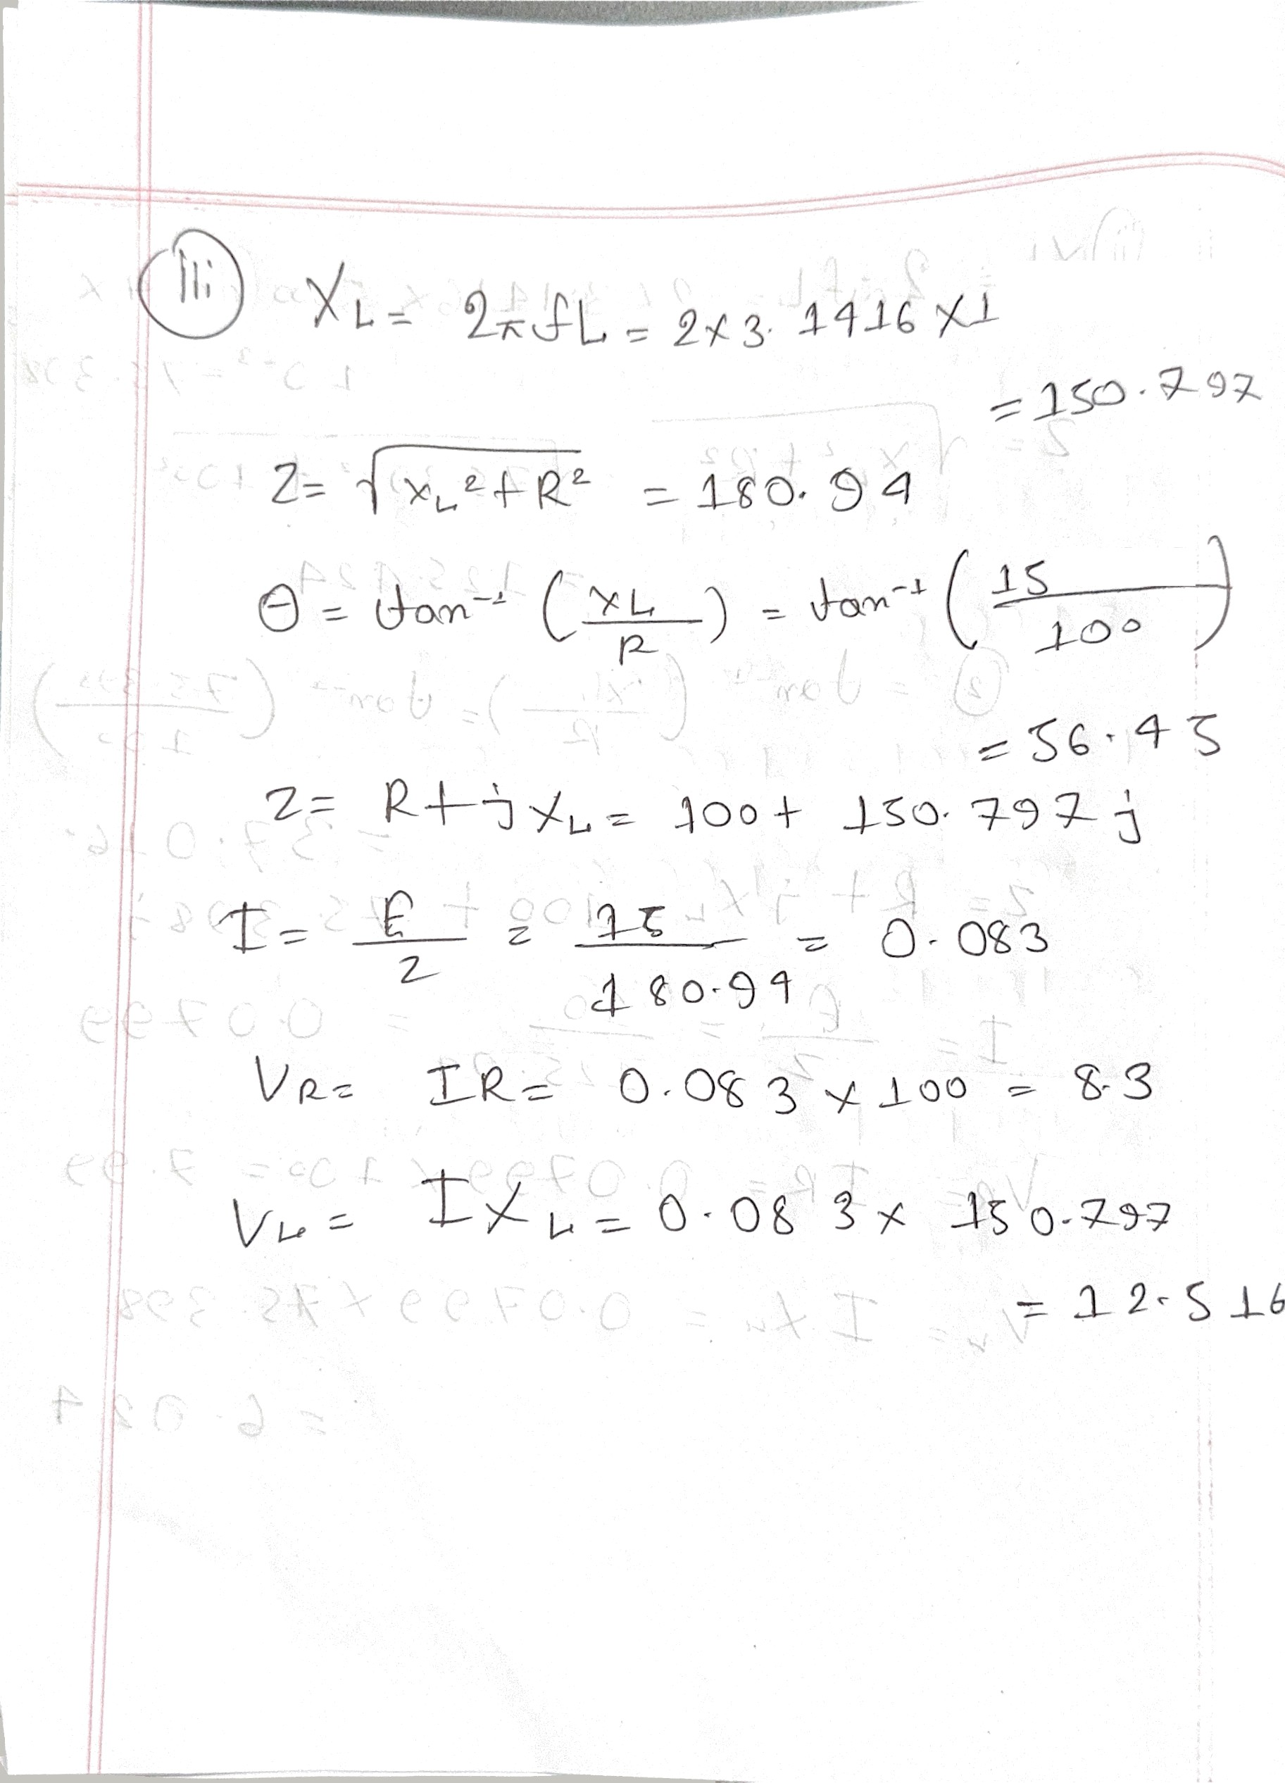

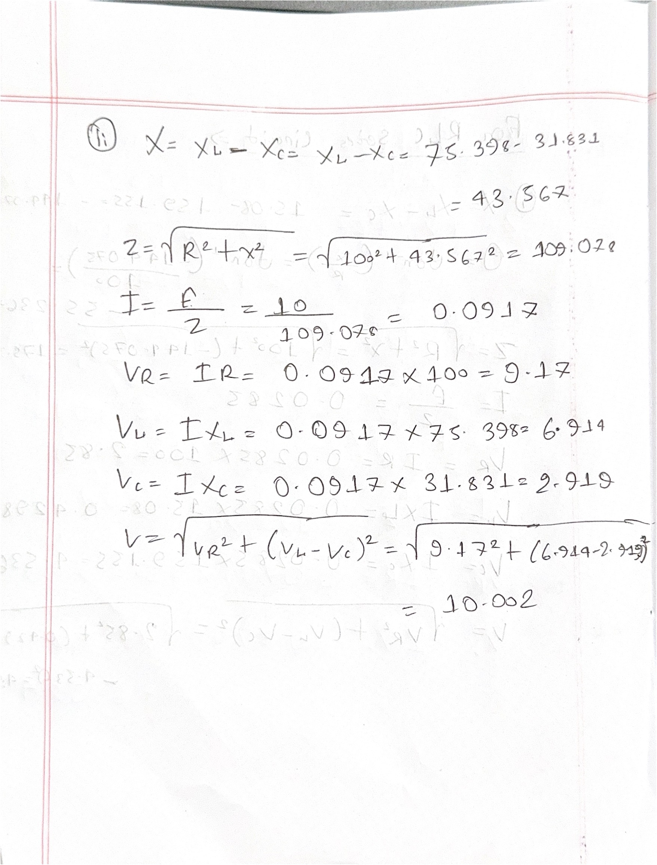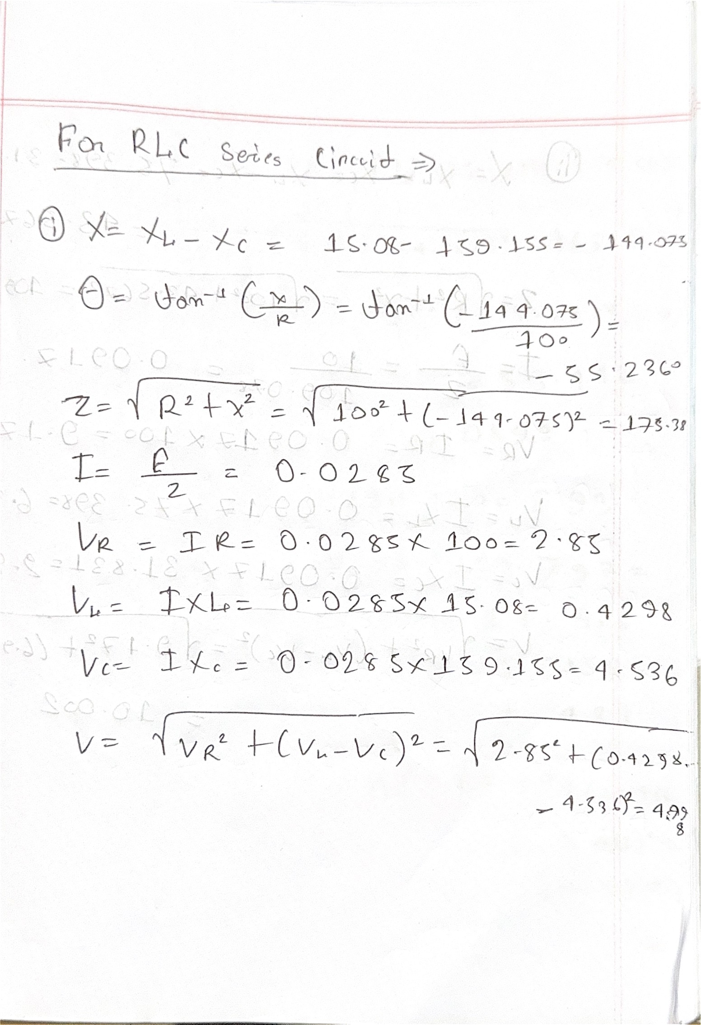

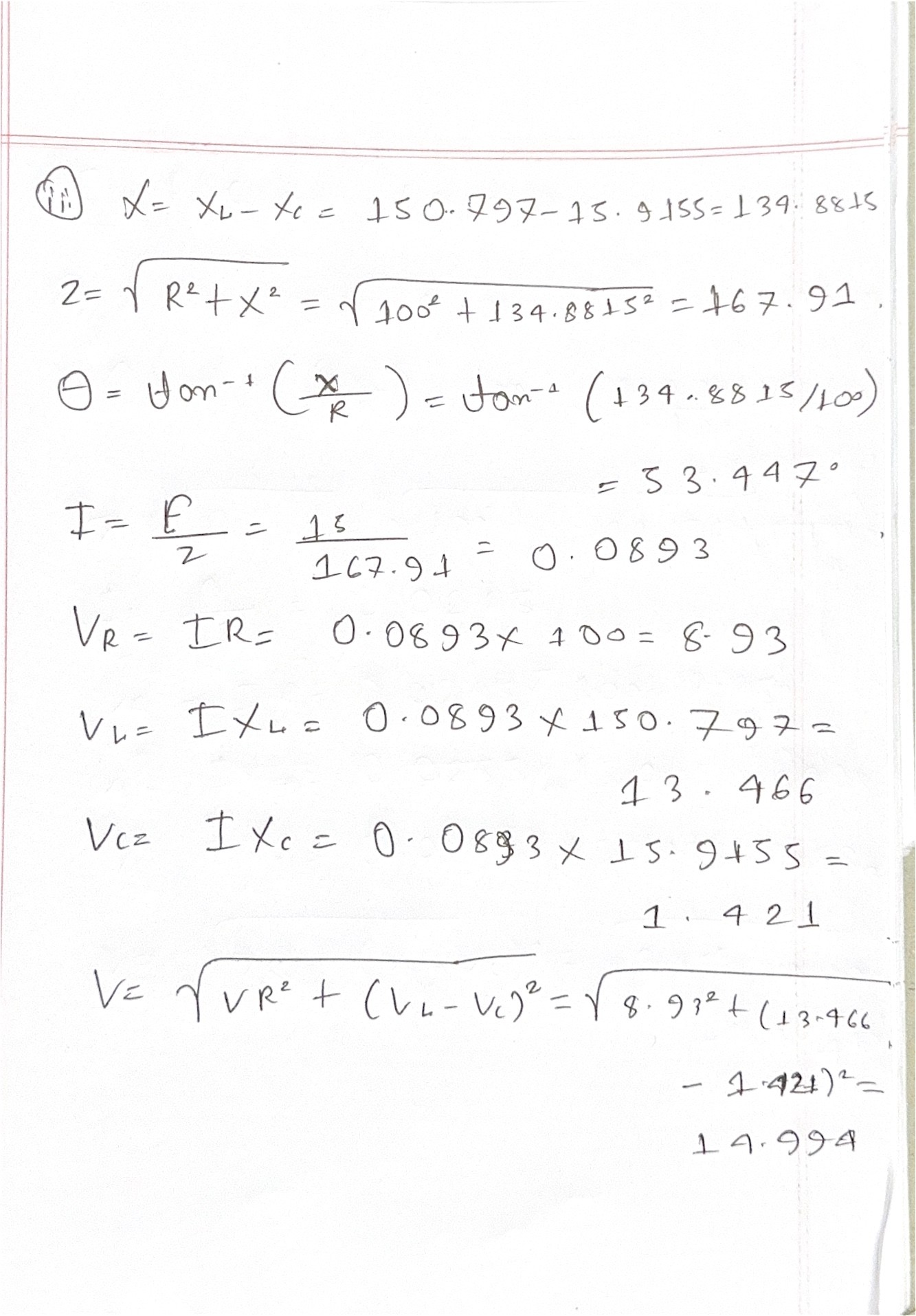

***Discussion***

In this experiment, first of all we checked the oscilloscope and then we started calibration. Then we gave frequency to the function generator to get respective sinusoidal wave. We made sure that the peak to peak value was 5V. After doing all these things we got a value which was very close to our expected value.

***Conclusion:***

By completing this experiment we had become familiar with function generator and oscilloscope. Measuring RC, RL, RLC series circuits and we verified KVL in RLC series circuit.